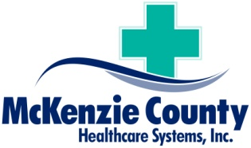 Memorandum
From: Daniel Kelly, CEO
Date: October 7, 2020
Re: Chief Financial Officer
Message:
A challenging and rewarding career opportunity for an Chief Financial Officer is currently available at the McKenzie County Healthcare Systems, Inc. (MCHS) The healthcare system is seeking a dynamic results driven individual, who is hands on.
The healthcare system consists of a Critical Access Hospital, Skilled Nursing Facility, Basic Care Facility, Assisted Living, Wellness Center, Rural Health Clinic, Specialty Clinic, and the Urgent Care Clinic. We are located in Watford City, North Dakota.
The McKenzie County Healthcare System, Inc. seeks someone who is collaborative, insightful and transformational. The Chief Financial Officer will receive a completive salary and comprehensive benefits with a bonus potential. A related Bachelor Degree is required and possession of a CPA is desired. A demonstrated awareness of Critical Access Hospital finance and reimbursement is required.
A cover letter and resume should be directed to: Director of Human Resources, 709 4th Avenue, N.E., Watford City, North Dakota 58854.

